Name : Dhruv Deshmukh

Reg No : RA2111028010125

Year : 2nd Year

Section : P1

Course Teacher : Dr. B. Balakiruthiga

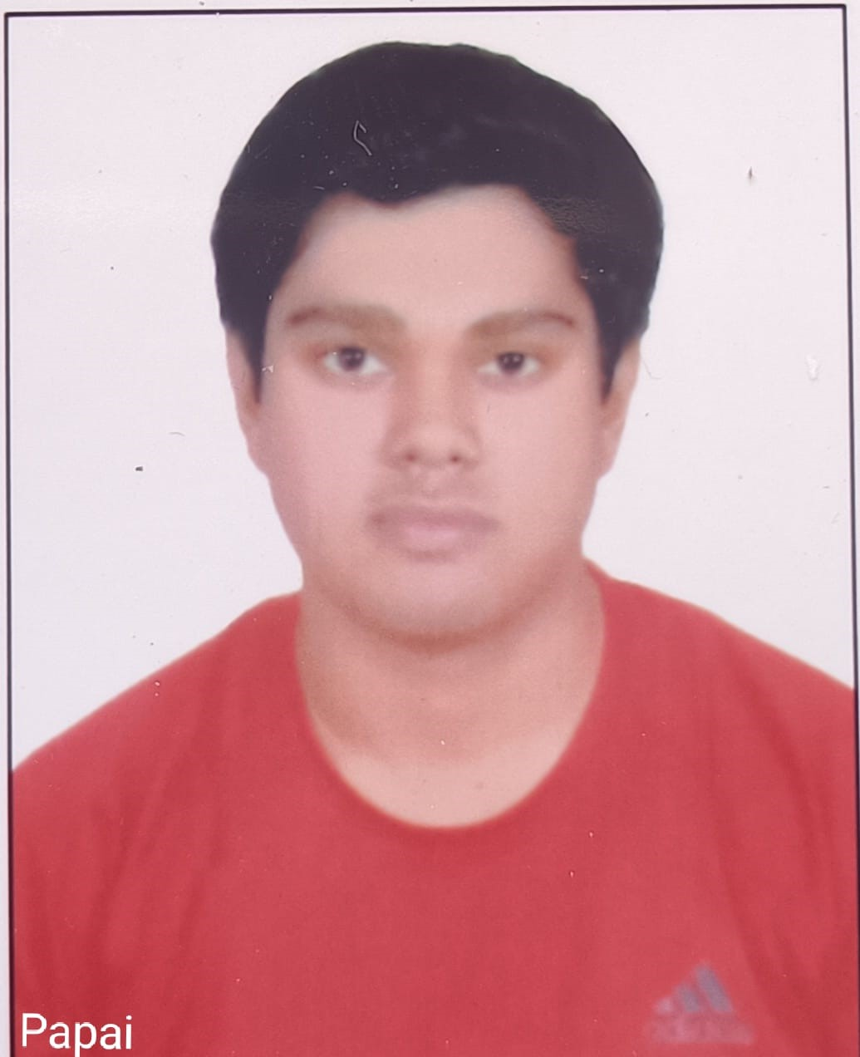

**DATABASE MANAGEMENT SYSTEMS AND CLOUD INTEGRATION SERVICES – 18CSC109J**

**B.Tech CSE (Cloud Computing)**

**Student Portfolio**

**List of Assignments:**

* SQL Query formulation
* ER Diagram
* Normalization of Database
* PLSQL Programs

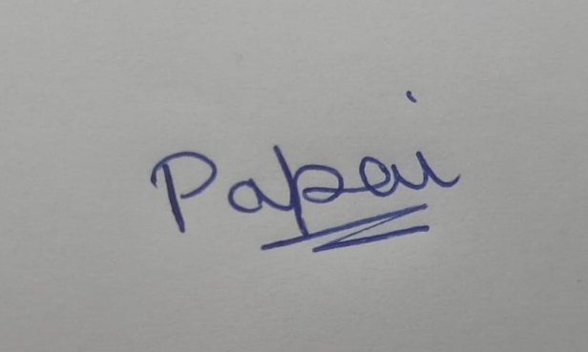

Signature of the student